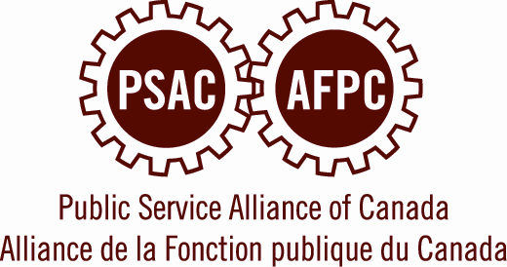
Memorandum

XO/21/15

To: National Board of Directors
Management Team

From: Robyn Benson

Date: July 3, 2015

Re: Update – Transition Process

At the PSAC Convention in May, delegates adopted a budget which contains within it a transition process, which is designed to help PSAC make the transition to a slightly smaller organization, as a result of recent drops in membership and revenues. We agreed to undertake this process to ensure that the PSAC has the strong and focused programs, priorities and operations it needs and wants in order to defend the interests of our members.

Delegates also approved a $4 million Transition Fund to assist in the process. This fund will allow us to undertake a thorough strategic planning process, and to consult widely with elected officers, members, and staff about the programs and priorities and operations of the union. It will also help the PSAC implement any needed organizational changes in a way which minimizes the impact on PSAC staff and our current programs and services.

As the NBoD, we had the chance to discuss the transition process on more than one occasion, and our initial plan had been to actively commence the transition work in June of this year.

However, Convention also gave us a very strong mandate to actively campaign for public services, for public service workers, and for free collective bargaining, in advance of the federal elections on October 19. Currently, all of our energies are concentrated on having this campaign reach our members and the general public, and on engaging activists in getting members out to vote in favour of candidates that respect worker and union rights as well as federal public services.

This must remain our focus and priority at a leadership, staff, and activist level, right through until the polls close on October 19.
In addition, the results of the October 19 election will significantly affect the opportunities and challenges we will face as a union over the next several years.

Consequently, I believe that we can only actively commence the transition process after we know the results of the 2015 federal election. It is, therefore, my intention to have a proposal for the transition process brought forward to the regular meeting of the NBoD at the end of October. We would then proceed with a broad consultation and planning phase that would run from November 2015 through to the fall of 2016, and the implementation phase would begin no later than January 2017.

This timeline will allow for active involvement at the level of the AEC and NBoD, engagement with PSAC leaders and activists at the Component and regional levels, and with PSAC staff and their internal unions. It will also allow us to undertake some broader consultations with the membership as a whole.

I have asked Brother David Orfald, former Director of Planning and Organizational Development (2006-10) and former Director of the Collective Bargaining Branch (2010-13) to head up the development of a plan for the transition process, and to coordinate the consultation and planning phase through until the end of 2016. David will take up these duties starting August 24. Leading up to the October meeting of the Board, I will also be asking elected and staff leadership to assist in the development of the plan for the transition process.

In solidarity,

Robyn Benson
National President

